AUTOTROPHIC NUTRITION

Autotrophic (Greek: auto – ‘self’; trophic – ‘feeding’) organisms take in inorganic carbon e.g. carbon dioxide and energy, to form complex organic compounds.

Types of Autotrophs
(1) Phototrophs - organisms which synthesize organic compounds using light energy. e.g. all green plants, algae, cyanobacteria, blue-green bacteria, green sulphur bacteria, purple sulphur bacteria, colourless sulphur bacteria.
(2) Chemotrophs - organisms which synthesize organic compounds using energy extracted from oxidation of inorganic chemicals by the process called chemosynthesis e.g. Nitrosomonas and Nitrobacter

CHEMOSYNTHESIS
Chemosynthesis: chemical process in which inorganic chemicals are oxidized to provide energy to living organisms for the synthesis of organic compounds.
Chemosynthetic bacteria | Substrate | Main product | Habitat
Nitrosomonas and Nitrococcus | Ammonium (NH₄⁺) | Nitrite (NO₂⁻) | Soil
Nitrobacter | Nitrite (NO₂⁻) | Nitrate ((NO₃⁻) | Soil
Thiobacillus | Sulphur (H₂S) | Sulphate (SO₄²⁻) | Decaying organic matter
Ferrobacillus / Iron bacteria | Ferrous (Fe²⁺) | Ferric (Fe³⁺) | Streams flowing over iron rocks
Hydrogenomonas | Hydrogen (H₂) | Water (H₂O) | Soil

Importance of chemosynthesis
The chemical activities of the organisms involved bring about nutrient cycling; for example:
- Nitrosomonas and Nitrobacter bacteria are involved in nitrification in plants.
- Thiobacillus catalyse the conversion of sulphur containing compounds to sulphates which are directly useful to plants.

Mechanism of chemosynthesis in some bacteria
Nitrosomonas
NH₃ + 3O₂ HNO₂ + H₂O + energy (79 kcals)

Nitrobacter
HNO₂ + O₂ HNO₃ + energy (22 kcals)

Thiobacillus
H₂S + 2O₂ SO₄²⁻ + 2H⁺ + Energy

The chemosynthetic bacteria utilize the energy from the chemical oxidation of inorganic chemicals to synthesize organic compounds, some of which are subsequently oxidized in respiration to yield energy for metabolism.

6CO₂ + 12H₂S C₆ H₁₂O₆ + 6H₂O + 12S

PHOTOSYNTHESIS
It is the formation of complex organic substances inside the cell containing chlorophyll from carbon dioxide and water using sunlight energy.

Importance of photosynthesis
1. It is the means by which the sun’s energy is captured by plants for use by all organisms.
2. It provides a source of complex organic molecules for heterotrophic organisms.
3. It releases oxygen for use by aerobic organisms.
4. It reduces on gaseous carbon dioxide, which would accumulate in the atmosphere to cause green house effect.

GENERAL ADAPTATIONS OF LEAVES FOR PHOTOSYNTHESIS
Adaptations for obtaining sunlight
1. Phototropism causes shoots to grow towards light in order to obtain energy.
2.Etiolation causes rapid elongation of shaded shoots to enable access to light.
3. The mosaic leaf arrangement minimizes leaf overlap and reduces leaves shading each other.
4. Leaf large surface area enables capturing maximum sunlight.
5. Thinness of leaves enables maximum light penetration.
6. The transparence of leaf cuticle and epidermis allow light penetration into the photosynthetic mesophyll.
7. The palisade mesophyll cells are densely packed with chloroplasts to trap much light.
8. Cyclosis (movement of chloroplasts within the mesophyll cells) allows repositioning in the direction of light.
9. The chloroplasts hold chlorophyll in an ordered way on the sides of the grana to present maximum chlorophyll to the light and also bring it close to other pigments / substances necessary for functioning.
10. Multiple cell layers in the palisade mesophyll of sun plants increases photosynthetic efficiency.

Adaptations for gas entry and exit | Adaptations for liquid entry and exit
1. Numerous stomata are present in the epidermis of leaves to enable entry and exit of gases.  2. The guard cells bordering stomata pores can be opened and closed to regulate the uptake of carbon dioxide and the loss of water.  3. Spongy mesophyll possesses many airspaces to enable faster and uninterrupted diffusion of gases between the atmosphere and the palisade mesophyll which wouldn’t happen if the gases were to diffuse through the cells themselves, a process which would be much slower. | 1. A large central midrib containing a large vascular bundle comprising xylem and phloem tissue is possessed by most dicotyledonous leaves for the entry and transport of water and mineral salts, and the phloem for carrying away sugar solution, usually in the form of sucrose.  2. A network of small veins is found throughout the leaf to ensure that every cell is close to xylem vessel or phloem sieve tube for constant supply of water for photosynthesis and a means of removing the sugars they produce.

CHLOROPLAST STRUCTURE
Chloroplast shape and size vary from biconvex in higher plants with length of ~5 µm to filamentous in algae, spherical, ovoid, etc.  It is enclosed by an envelope of double membranes; outer membrane is semi- permeable.  Inner membrane surrounds the stroma, regulates entry and exit of materials to the chloroplast, and is a manufacturing centre for fatty acids, lipids and carotenoids.  Intermembrane space is narrow, ~10 nm-20 nm in between the outer and inner membranes.  Stroma is semi-gel-like fluid, alkaline, rich in protein (e.g. enzymes), with chloroplast DNA, 70S ribosomes, starch granules, lipid globules and thylakoid membrane system.  Thylakoids are interconnected, membranous sacs, with chlorophyll in the membranes.  At intervals, thylakoids form piles (~10-20) known as grana. | 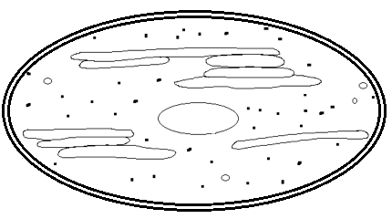  Granum  Outer membrane  Inner membrane  Thylakoid  Intergrana  lamella  Stroma  Starch grain  Lipid globule  70S ribosome  Adaptations of chloroplast for its functions  Outer membrane is semi- permeable to regulate entry and exit of substances for maintaining internal chloroplast environment.  Abundant light trapping pigments for photosynthesis  Abundant enzymes catalyse photosynthetic reactions in the stroma.  Extensive network of thylakoid membranes increase surface area for photosynthesis.  Narrow intermembrane space enables H⁺ ion concentration gradient to be rapidly established for chemiosmosis to occur  Inner membrane contains molecules for electron transport pathway  DNA presence codes for protein synthesis, including enzymes.  Many ribosomes for protein synthesis to reduce on importing proteins from cytoplasm.  Outer membrane is permeable to gases like carbon dioxide which is a raw material for photosynthesis.

CONDITIONS NECESSARY FOR PHOTOSYNTHESIS
1. Carbon dioxide, 2. Water, 3. Light, 4. Photosynthetic pigments

Condition | Explanatory notes
1. Carbon Dioxide | Land plants obtain CO₂ (1) by diffusion via stomata (2) by absorbing CO₃²⁻ from soil via roots.  Aquatic plants absorb dissolved bicarbonates through their general surface to carbon dioxide.  Air contains about 0.04% (400 ppm) by volume carbon dioxide while it is variable in water
2. Water | Water provides the H⁺ ions (protons) and electrons for the reduction of carbon dioxide.  2 H₂O O₂ + 4(H)  4(H) + CO₂ CH₂O + H₂O
3. Light | Three important properties of light: (i) quality/colour (ii) intensity/brightness (iii) duration/time.  Light is electromagnetic energy propagated in discrete particles called photons or quanta

ELECTROMAGNETIC RADIATION
Electromagnetic radiation is a form of energy transmitted through a vacuum (empty space) or a medium (such as glass) in which electric and magnetic fields are propagated as waves.
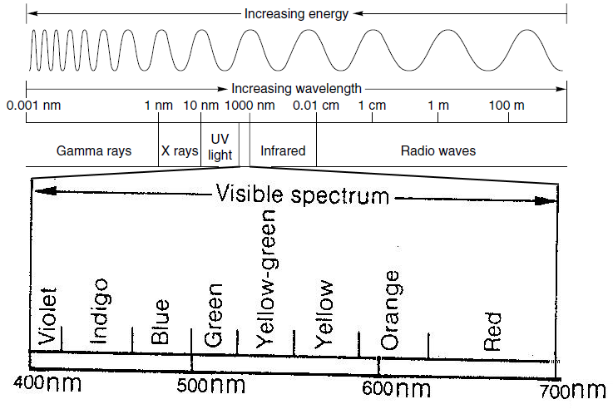
The electromagnetic spectrum consists of eight types of radiations:
(1) Cosmic rays (2) gamma rays (3) x-rays (4) ultra-violet rays (5) visible light spectrum (6) infrared rays (7) electric rays and (8) radio rays.

The shorter the wavelength, the greater the frequency.
Light with a short wavelength has more energy than light with longer wavelength e.g. Blue light (wavelength 400nm) has more energy than a photon of red light (wavelength 700nm).

ORIGINS OF PHOTOSYNTHETIC LIGHT
1. Incandescence: The emission of light from hot matter e.g. the sun. The hotter the material, the shorter the wavelengths of emitted light, the more the energy.
2. Luminescence: The emission of light when ‘excited’ electrons fall to a lower energy, emitting a photon e.g. the light-emitting diode bulbs in school labs, fluorescent lights, light from leaf extracts, etc.

NATURE OF LIGHT
Visible light is the part of the electromagnetic spectrum between the wavelengths of 400 nm and 740 nm, known as the photosynthetically active radiation (PAR).

FATE OF LIGHT THAT HITS A LEAF
Light interacts with a leaf in three ways:
1. Reflection (Reflectance): light can simply rebound off the leaf surface and hence never utilized in leaf photosynthesis.
2. Transmission (Transmittance) through the leaf, exiting from the underside.
3. Absorbance by the leaf, in which case the light might be used in photosynthesis.
Of the absorbed visible radiation, 70%, is used in photosynthesis while 30% is transmitted through the leaf.
 Blue and red are the most absorbed wavelengths, and green and far infrared wavelengths pass through.
Transmission depends on the thickness of the leaf; thin leaves transmit more light than thick leaves.
LIGHT IN A FOREST (SHADY ENVIRONMENT)
The amount of sunlight decreases as light penetrates down the vegetation layers because the amount of leaf area increases. Leaf area index is the one-sided leaf area per unit area of ground.
The leaf area index (LAI): LAI = m² leaf area/m² ground area
E.g.: 3 m² leaf area/m² ground area means there are 3 square meters of leaf area over each square meter of ground area.
The greater the leaf area over a surface, the lower the quantity of light reaching that surface.
FATE OF LIGHT IN A FOREST (SHADY ENVIRONMENT)
The graph beside shows the energy in light of different wavelengths reaching the ground in a forest.
Energy was measured in:
(1) Direct sunlight that passed through canopy gaps.
(2) Sunlight that had passed through tree leaves.
As light penetrates the canopy, different wavelengths are filtered out – light becomes attenuated (reduced):
(i) The denser (thicker) the canopy, the more weakening of light occurs.
(ii) Leaves with whitish hairs and cuticle reflect more light than deep green leaves
(iii) The smaller the size of gaps in the canopy, the more weakening of light.
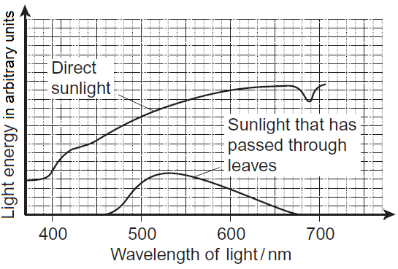

Observations
1. All the wavelengths of direct light reach the ground because this light passes through gaps left by leaves hence no wavelength is filtered out.
2. Of the light that passes through leaves, only wavelengths in the range 460 nm – 670 nm reach the ground (high transmittance to the ground) because of low/no absorption by chlorophylls in the leaves.
3. Wavelengths of visible light below 460 nm and above 670 nm do not reach the ground after passing through leaves (no transmittance) because of much absorption by photosynthetic pigments e.g. chlorophylls.
4. Of the light that passes through leaves, wavelength 525 nm reaches the ground with most energy because it is least absorbed by photosynthetic pigments.

4. PHOTOSYNTHETIC PIGMENTS
Chlorophylls and carotenoids absorb light energy required in photosynthesis.
Carotenoids also protect chlorophyll from photo damage.

Photosynthetic Pigment | Distribution (occurrence) | Properties
Chlorophyll a | All photosynthetic plants  i.e. It is the most abundant | Bluish green in pure state  Very soluble in ether, and also soluble in lipid solvents e.g. chloroform, carbon tetrachloride, alcohols, etc
Chlorophyll b | Higher plants | Olive green (yellow green) in pure state.  Very soluble in methyl alcohol and also soluble in lipid solvents e.g. chloroform, carbon tetrachloride, etc
Bacteriochlorophyll | (1) Purple sulphur Bacteria,  (3) Green sulfur bacteria | ● Are related to chlorophylls  Conduct photosynthesis, but do not produce oxygen.  Absorbs wavelengths of light not absorbed by plants
CAROTENOIDS  (a) xanthophylls e.g. lutein  (b) carotenes e.g. α-carotene, lycopene | Occur in chloroplasts of plants, algae, some bacteria, and some types of fungi | Xanthophylls are often yellow, Carotenes vary in colour: pale yellow, bright orange, deep red.   Are soluble in fat solvents e.g. ether, chloroform, acetone.  Carotenes are closely related to the vitamin A

Chlorophyll b and carotenoids are accessory pigments i.e. they hand over energy absorbed to chlorophyll a.
Chlorophyll belongs to a class of organic compounds called porphyrins which have 4 pyrrole rings.
Other porphyrins are haem and the cytochromes.
However, Chlorophyll contains magnesium atom instead of iron.
SUN AND SHADE LEAVES
Sun leaves are those that grow on branches exposed to direct sunlight while shade leaves grow on branches exposed to light that has passed through leaves.
In low light, plants need to maximise light absorption for photosynthesis to exceed respiration if they are to survive.
In high light environment, plants maximise their capacity for utilising abundant light energy, while at the same time dealing with excess sunlight which can bleach chlorophyll.

ADAPTATIONS TO PHOTOSYNTHESIZE IN SUN AND SHADE
Adaptation: a genetically determined capability to acclimate to environmental condition.

Shade plant | Sun plants
1. Abundant chlorophyll b (low chlorophyll a to chlorophyll b ratio) which gives leaves dark green colour to increase light absorption in the dark;  2. Palisade/ spongy mesophyll ratio low to allow maximum light penetration;  3. Mesophyll cell surface / leaf area ratio low to maximise light trapping;  4. Leaf orientation horizontal to maximise light trapping;  5. Reddish leaf undersides to enhance reflectance back up through the photosynthetic tissue; giving the plant a second chance to utilize the light.  6. Stomatal density low to avoid over cooling;  7. Thin leaves to maximise light penetration;  8. Stomatal size large to allow loss of excess water;  9. Elongated internodes for increased access to light;  10. Chloroplast size large to increase the surface area for storage of photosynthetic pigments. | 1. Abundant chlorophyll a (high chlorophyll a to chlorophyll b ratio) to increase light absorption;  2. Palisade/ spongy mesophyll ratio high to minimise light penetration;  3. Mesophyll cell surface / leaf area ratio high to minimise excessive light and transpiration;  4. Leaf orientation erect to minimise light trapping;  5. Stomatal density high to avoid over heating;  6. Much carotenoids to prevent damage to chlorophyll from very bright light.  7. Thick leaves to minimise light penetration;  8. Stomatal size small to minimise water loss;  Other features  (i) RuBISCO and soluble protein content /mass higher  (ii) Chlorophyll / soluble protein ratio high  (iii) Chloroplast size small

PHOTOSYNTHETIC PIGMENTS IN SUN LEAVES AND SHADE LEAVES OF BEECH TREE
Photosynthetic pigment | Mean mass of each pigment per m² of leaf area / μg
Photosynthetic pigment | Sun leaves | Shade leaves
Chlorophyll a | 299.3 | 288.9
Chlorophyll b | 90.7 | 111.1
Carotenoids | 0.10 | 0.07
Graphically, the data can be reflected by a bar graph.

COMPARISON OF DISTRIBUTION OF PHOTOSYNTHETIC PIGMENTS
The ratio of chlorophyll a : chlorophyll b is bigger in sun leaves than shade leaves (Sun leaves contain more chlorophyll a than shade leaves) because chlorophyll a is more effective at absorbing the light wavelengths available to sun leaves e.g. about 450 nm.
Shade leaves contain more chlorophyll b than sun leaves because in shade plants chlorophyll b improves light-capturing capability of the chloroplast.
Sun leaves contain more carotenoids than shade leaves because carotenoids are accessory pigments that shield chlorophylls from destruction by excessive sunlight.

Why few species of plant can survive under shady habitats.
Less direct light reaches ground via gaps in the canopy hence minimum energy is available for effective photosynthesis.
Of the light that passes through leaves, only a small range of wavelengths reaches the ground, which is not effective for photosynthesis.
Therefore, under shady habitats little light energy is available for chlorophyll to absorb and hence photosynthesise is insufficient for growth.

DESCRIPTION OF CHLOROPHYLL MOLECULE STRUCTURE
● Chlorophyll molecule has a tadpole-like structure, with a hydrophilic head called porphyrin and a hydrophobic tail made up of long chain alcohol called phytol.
● The flattened head is made up of four nitrogen containing pyrrole rings (labelled I-IV) which are linked by methine bridges (-CH=).
● The skeleton of each pyrrole ring is made up of 5 atoms - four carbon and one nitrogen. The nitrogen lies towards the centre.
● A magnesium atom is held in the centre of porphyrin head by nitrogen atoms of pyrrole rings using 2 covalent and 2 coordinate bonds.
● Chlorophyll b differs from chlorophyll a in having the group (-CHO) instead of a methyl group (-CH₃) at position R (carbon 3).

NB: The phytol tail anchors and orients the chlorophyll molecule in the chloroplast’s thylakoid membrane

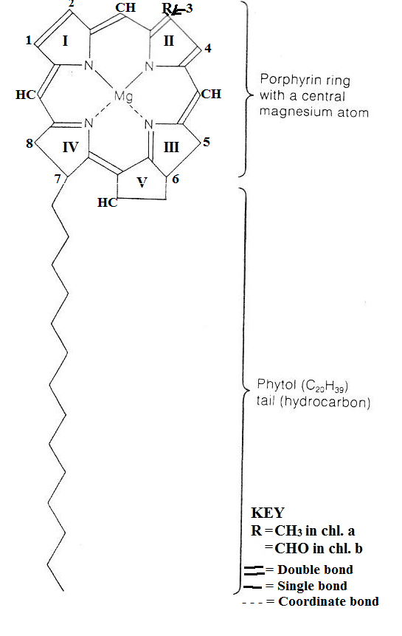
ABSORPTION SPECTRUM OF PHOTOSYNTHETIC PIGMENTS
It is a graph of the relative absorption of different wavelength of light by a pigments like chlorophyll. It is measured by a spectrophotometer

ACTION SPECTRUM OF PHOTOSYNTHESIS
A graph of the effectiveness of different wavelengths of light in stimulating the photosynthetic process. It represents the actual rate of photosynthesis in living cells.
Absorption spectra of chlorophylls a & b, and carotenoids and the action spectrum of photosynthesis
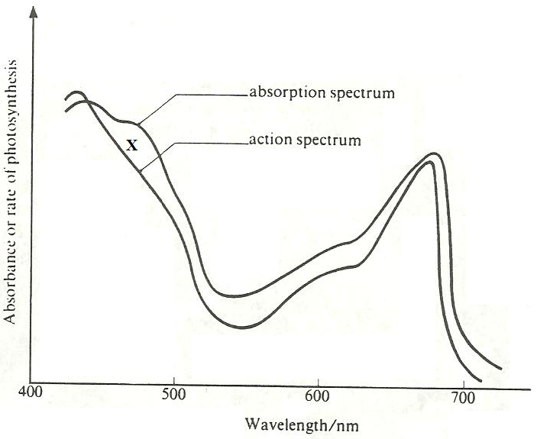
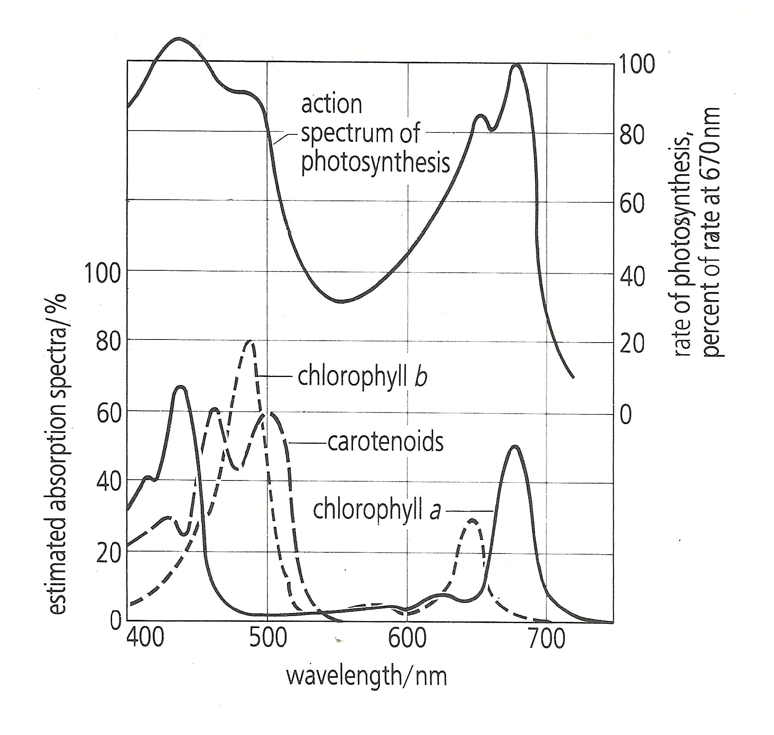

Observations | Explanation
● The action spectrum of photosynthesis corresponds closely to the absorption spectra of chlorophyll a and b. | ● This indicates that most of the wavelengths of light absorbed by chlorophyll are used in photosynthesis.
● There is non-correspondence of action spectrum of photosynthesis with absorption spectra at point marked ‘X’ | ● This is because it is at ‘X’ where there is maximum absorption by carotenoids, which are not used in photosynthesis.
● The wave lengths of about 550 nm to 620 nm have the lowest absorption and action spectra for all the photosynthetic pigments. | ● The unabsorbed (reflected light) appears green, thus making chlorophyll, the chloroplasts and the leaves that contain it appear green to our eye.
● There are two absorption maxima of lambda = 430 nm and lambda = 662 nm for chlorophyll a, and 453 nm and 642 nm for chlorophyll b, but only one maximum for carotenoids at about 510 nm. | ● This shows that chlorophyll a as well as b are the main photosynthetic pigments, however, photosynthesis also occurs in the mid part of light spectrum where carotenoids are active.
● The action spectrum peaks within the blue-violet and red regions of the light spectrum. | ● This shows that maximum photosynthesis occurs in red part and blue-violet part of visible light.
OTHER OBSERVATIONS
● Chlorophyll a absorption in red light is about twice that of chlorophyll b and the absorption peak is at a slightly longer wavelength (lower energy)
● Absorption of chlorophyll a in the blue is lower and shifted to a slightly shorter wavelength (higher energy).

ENGELMANN’S EXPERIMENT ON ACTION SPECTRUM OF PHOTOSYNTHESIS
Description of Engelmann’s experiment | Results of Engelmann’s experiment
Filaments of the green alga Cladophora of the genus Pseudomonas are placed in a drop of water on a slide, then illuminated with light of different wavelengths and observed under the microscope.  The control experiment involves mounting the alga on a slide in water with aerobic bacteria in total darkness and thereafter exposing the slide to light.   Observation 1:  The motile aerobic bacteria cluster near to the filaments in the region of blue light (450 nm) and red light (650 nm).   Deduction 1:  Since the distribution of aerobic bacteria is in response to the concentration of oxygen which is a by-product of photosynthesis, then red and blue light are the most effective for photosynthesis.   Observation 2:  Motile aerobic bacteria cluster around the edge of the cells adjacent to the chloroplast.   Deduction 2:  Oxygen is more concentrated near the chloroplast which shows that the chloroplast is the sight of photosynthesis.   Observation 3:  The aerobic bacteria of the slide previously in the dark are immobile but later cluster around the alga filament on exposure to light. | 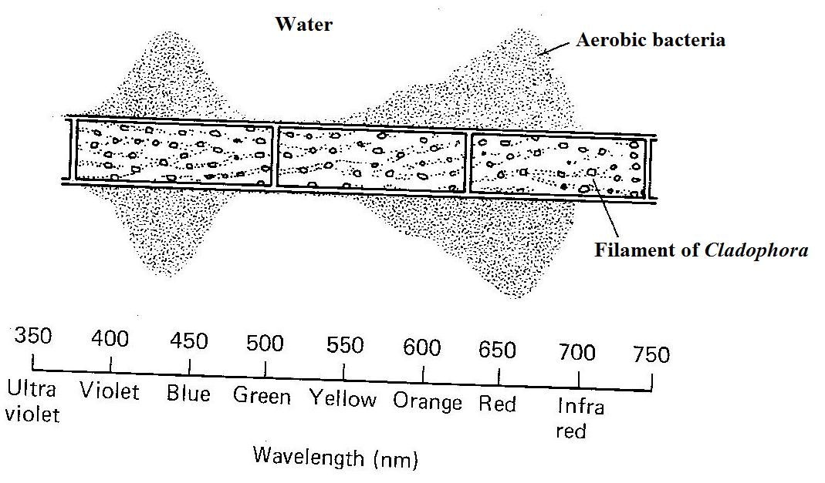   Deduction 3:  Darkness prevents photosynthesis, which stops evolution of oxygen resulting in anaerobic conditions that donot favour aerobic bacterial activity   Observation 4:  There is hardly any aerobic bacteria in the ultra-violet, green and infra-red regions of the spectrum.   Deduction 4:  Light from ultra-violet, green and infra-red regions of the spectrum is hardly absorbed by chlorophylls hence least used in photosynthesis, with no / little evolution of oxygen.

MECHANISM OF PHOTOSYNTHESIS
Photosynthesis is an oxidation-reduction process, in which water is oxidized to release oxygen and carbon dioxide is reduced to form carbohydrates.

PHASES OF PHOTOSYNTHESIS
[1] Light stage (Photochemical reactions or Hill reaction) [2] Dark stage (Biochemical reactions).

LIGHT DEPENDENT PHASE
● It takes place in the thylakoid membranes of chloroplasts.

The main functions are:
(1) Photophosphorylation i.e. addition of an inorganic phosphate to Adenosine diphosphate (ADP) to form Adenosine triphosphate (ATP) using light energy.
(2) Formation of NADPH⁺ which is the reduced form of Nicotinamide adenine dinucleotide phosphate.

DESCRIPTION OF LIGHT STAGE OF PHOTOSYNTHESIS
Its reactions are triggered by light energy exciting photosystems I and II inside the thylakoid membranes at the same time, not one after the other.
THE Z-SCHEME SUMMARISING LIGHT STAGE | OPERATIONS OF PHOTOSYSTEMS I AND II
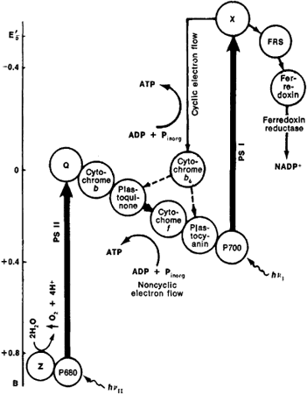 | Chlorophyll molecules of PSII and PSI are excited by light of wavelength 680 nm and 700 nm respectively; causing the loss of electrons to a chain of electron carriers in a series of reduction-oxidation reactions as follows:  (i) From PSI, some electrons may flow:  (1) Cyclically to iron-protein complex, cytochromes b₆, plastoquinone, cytochrome-f, plastocyanin and back to P-700, during which electrons lose energy to form ATP from ADP and Pi.  (2) Non-cyclically (Unidirectionally) to unknown molecule A, iron-protein complex, Ferrodoxin, Flavin-Adenine Dinucleotide (FAD) which becomes reduced (FADH), finally to NADP to form reduced NADP (NADPH).  (ii) From PSII to the unknown molecule Q, substance B, plastoquinone (PQ), cytochrome f, plastocyanin, (a copper enzyme), and finally to PSI, to replace the electrons earlier lost. During this flow, electrons lose energy to phosphorylate ADP to form ATP.  The flow of electrons through carriers in the thylakoid membranes releases energy for active pumping of hydrogen ions (H⁺) from the stroma into the thylakoid space.   At the same time, photolysis of water:  (1) Causes accumulation of H⁺ inside the thylakoid space.  (2) Provides electrons to replace those lost from PSII, with evolution of oxygen molecule.  Chemiosmosis occurs i.e. the highly concentrated H⁺ inside the thylakoid space diffuse along the steep electrochemical gradient from the thylakoid space via the stalked particles into the stoma, thereby providing:  (1) energy to form ATP in the presence of ATPase enzyme  (2) H⁺ for reducing NADP to form NADPH, which together with the ATP formed enter the dark stage.

NOTE
The loss of 2 electrons by the chlorophylls in the photosystems bleaches the chlorophyll molecule. In this state, it can no longer absorb light energy effectively. Therefore, the electrons lost to the electron transfer chain must be replaced.

WHAT IS MEANT BY?
Chemiosmosis: It is the movement of ions across a selectively permeable membrane down an electrochemical gradient.
Z-Scheme: It is a diagrammatic representation of electron flow in cyclic phosphorylation and non-cyclic phosphorylation, showing the change in energy potential of the electrons.

COMPARISON OF CYCLIC AND NON-CYCLIC PHOTOPHORYLATION
Similarities
In both:
(1) there is flow of electrons through several electron carriers (2) there are pigment systems which accept and lose electrons (3) ATP is formed (4) pigment system I is involved (5) electron movement is located in the thylakoid membranes (6) protons are moved outwards of the thylakoids (7) protons (H⁺) are actively pumped from stroma into thylakoid space (8) there is photo-excitation of electrons in the pigment systems.

Differences
NON-CYCLIC PHOTOPHORYLATION | CYCLIC PHOTOPHORYLATION
● Electrons flow unidirectionally (non-cyclically) | ● Electrons flow cyclically
First electron donor is (source of electrons) water | First electron donor is pigment system I (PSI)
Last electron acceptor is NADP | Last electron acceptor is pigment system I (PSI)
The products are ATP, NADPH and Oxygen | The product is ATP only
Involves both pigment systems I and II | Involves only pigment system I
Photolysis of water occurs | No photolysis of water

ROLE OF WATER IN PHOTOSYNTHESIS
● Catalytic photolysis / splitting / breaking of water produces electrons (e⁻) and protons (H⁺).
● Water is a source of electrons to replace those lost by chlorophyll / photosystem II
● Water is a source of H⁺ needed to produce NADPH + H
● Water is a source of H⁺ which when flowing from thylakoid space into stroma via ATPase, ATP forms.
● Water is a substrate / reactant / raw material / for photosynthesis
● Water is transparent so photosynthesis can take place underwater / light can penetrate to chloroplasts

DARK REACTION [BIOSYNTHETIC PHASE OR BLACKMAN'S REACTION]
It’s called dark reaction because does not require light, although can take place in light also. It occurs in the stroma of chloroplasts.

THE MAIN PATHWAYS FOR THE DARK REACTION
(l) Calvin-Benson cycle / C₃ pathway (2) Hatch-Slack pathway / C₄ pathway

MAIN STAGES OF CALVIN-BENSON CYCLE (C₃ CYCLE)
C₃ Plants: Plants whose first stable product of photosynthesis is a 3-carbon organic compound called glycerate-3-phosphate
Triose phosphate (glyceraldehydes 3-phosphate) is the end product of the Calvin cycle / photosynthesis because all subsequent reactions can also occur in no-photosynthetic organisms like animals and fungi . (Soper R. et al (1997). Biological Science p210:7.7)
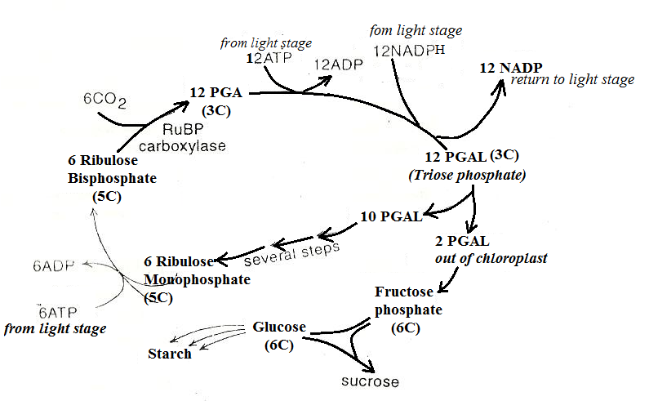

THREE MAIN STAGES OF THE CALVIN CYCLE
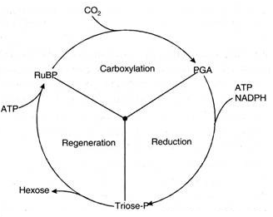 | 1. CARBOXYLATION  Catalysed by RuBP carboxylase, 6 molecules of RuBP react with 6 molecules of CO₂, and 6 molecules of water forming 12 molecules of 3-phosphoglyceric acid (PGA), which is the first carbohydrate made by C₃ plants.  2. PHOSPHORYLATION AND REDUCTION  12 molecules of PGA react with 12 molecules of ATP forming 12 molecules of 1, 3-diphosphoglyceric acid and 12 molecules of ADP.  12 molecules of NADPH (formed in light stage) reduce 12 molecules of-1, 3-diphosphoglyceric acid to form 12 molecules each of 3-phosphoglyceraldehyde (PGAL) / triose phosphate (TP), NADP and phosphoric acid.  Out of these 12 molecules of PGAL, only 2 molecules undergo isomerization and several reactions to form hexose sugar, sucrose or starch and 10 molecules are recycled to produce 6 molecules of ribulose monophosphate.
3. REGENERATION: The remaining 10 molecules of PGAL regenerate 6 molecules of ribulose-6-phosphate when 6 molecules of a 5-carbon sugar ribulose monophosphate react with 6 molecules of ATP (formed during light stage) to form 6 molecules of Ribulose-1,5-bisphosphate (RuBP) and 6 molecules of ADP.

Metabolism of Glycerate phosphate (GP) and Glyceraldehyde phosphate (TP / PGAL)
(a) Synthesis of carbohydrates: Glyceraldehyde-phosphate molecules are converted to form monosaccharides e.g. glucose, which may combine with fructose to form sucrose, transported in phloem sieve tubes or can be polymerized into starch for storage or cellulose.
(b) Synthesis of lipids: (i) Glycerate-phosphate enters glycolysis pathway and is converted to pyruvate, which can be converted into acetyl group, which combines with coenzyme A to form acetyl coenzyme A. This can be used to form a variety of fatty acids in th cytoplasm and chloroplast.
(ii) Glycerate-phosphate can also be converted to glycerol. Lipids such as triglycerides are esters of fatty acids and glycerol, which are important components of cell membranes.
(c) Synthesis of proteins: Glycerate-phosphate is converted into acetyl coenzyme A and enters into the Krebs cycle. Some of its intermediates can produce different amino acids by transamination reactions. The amino acids are then polymerized into proteins which are required for growth and development, synthesis of enzymes and structural components of the cell.

RELATIONSHIP BETWEEN PHOTOSYNTHESIS AND SYNTHESIS OF FOOD IN GREEN LANTS
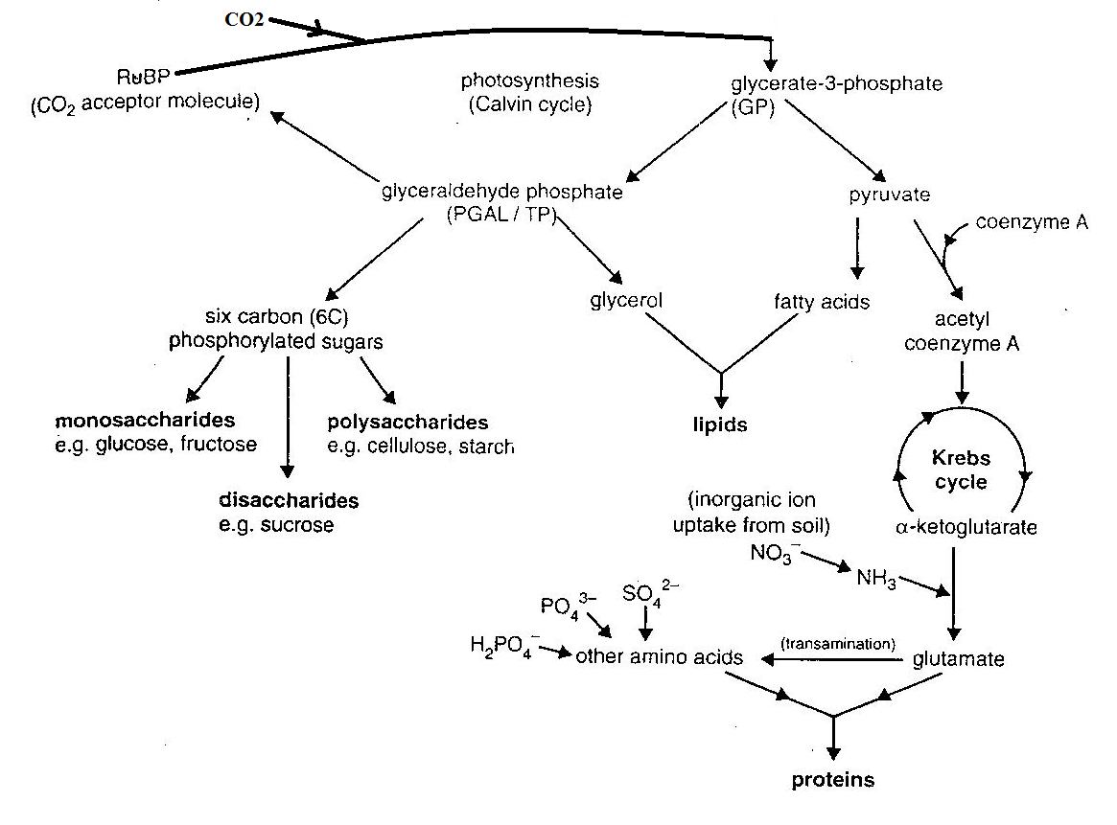
QUESTION:
The enzyme RUBISCO, in spite of being the most common enzyme in the world, is very inefficient in photosynthesis. Explain this statement.
1. RUBISCO can add approximately 3CO₂ to 3 molecules of RuBP each second, which is very slow for an enzyme. To make up for this, plants produce large quantities of RUBISCO, with it composing 50% of the protein in a chloroplast.
2. RUBISCO is not a very specific enzyme as it sometimes combines RuBP with oxygen rather than CO₂ because of a relatively non-specific active site, causing photorespiration which leads to the formation of a useless oxygenated intermediate, rather than carbon dioxide fixation.

WHAT IS PHOTORESPIRATION?
Oxygenation of RuBP by RuBP oxygenase (RUBP carboxylase) at high temperature, low carbon dioxide and high oxygen concentration to form phosphoglycolate which undergoes oxidation in peroxisomes and metabolism in mitochondria to release CO₂, thereby preventing carbon fixation in C3 plants.

HOW PHOTORESPIRATION AFFECTS PLANTS
When C3 plants are exposed to low carbondioxide concentration (or high oxygen concentration) e.g. when stomata close to reduce water loss, RuBP carboxylase catalyses the reaction between RuBP and oxygen to form a 2-carbon compound; phosphoglycolate, which is oxidized to release carbondioxide. Yet when the carbondioxide concentration is high, RUBISCO enzyme catalyses the reaction between RuBP and carbondioxide to form a 3-carbon compound; 3-phosphoglyceric acid, which undergoes several reactions to form sugar useful to the plant. It is estimated that Photorespiration therefore reduces the potential yield of photosynthesis by 30-40%.

THE HATCH-SLACK CYCLE OR C₄ PATHWAY
● C4 photosynthesis: type of photosynthesis in which the first stable product of CO₂ fixation is a four carbon compound called oxaloacetate (OAA) inside mesophyll cells, which is later reduced and exported into bundle sheath cells for further metabolism.
● Carbon 4 plants: plants in which the first product of carbon dioxide fixation is a four carbon compound called oxaloacetate (OAA) inside mesophyll cells, which is later reduced and exported into bundle sheath cells for further metabolism.
● Examples of C₄ plants: maize, sorghum, Amaranthus, Sugar cane, paspalum, Bermuda grass, rhodes grass, nut grass.
Fact: C₄ plants represent only 3% of the world’s vascular plants yet they contribute about 20% to the global primary productivity because of their high productivity.
● Habitats: hot / arid / saline tropical habitats.
● Description of leaf anatomy: Kranz.

WHAT IS KRANZ LEAF ANATOMY?
A condition in which bundle sheath cells and palisade cells of the mesophyll form two concentric layers (rings) around each vascular bundle of leaves.

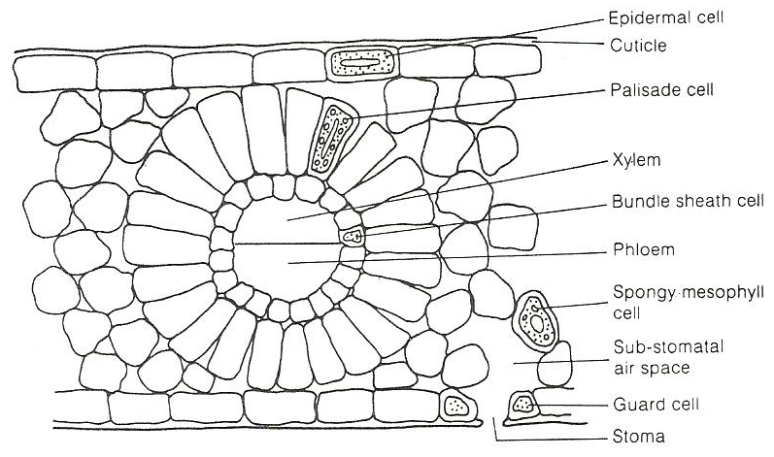
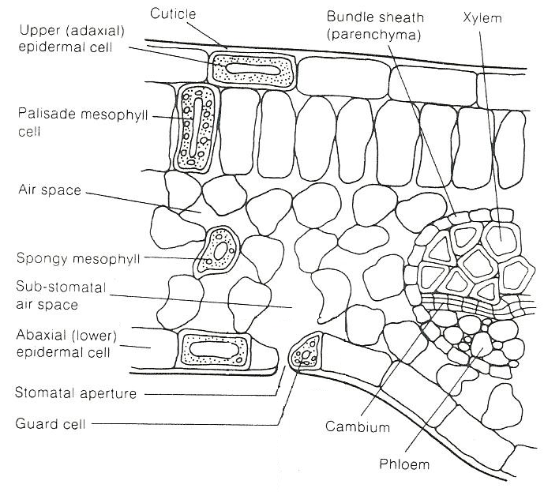
COMPARISON OF LEAF ANATOMY IN C₃ AND KRANZ ANATOMY IN C₄ PLANTS
Leaf anatomy in C₃ plants | Kranz anatomy in C₄ plants

DESCRIPTION OF C₄ CYCLE IN CO₂ FIXATION

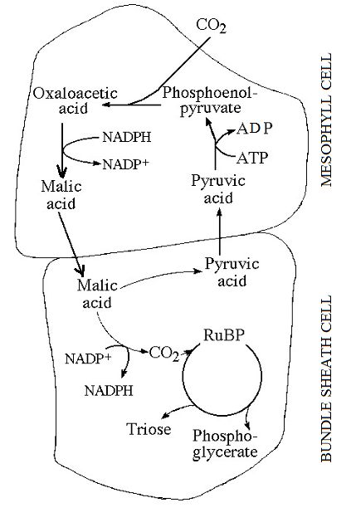 | 1. In the presence of phosphenol pyruvic acid carboxylase enzyme, Phosphenol pyruvic acid is carboxylated inside the chloroplasts of mesophyll cells to form oxaloacetic acid.  2. Oxaloacetic acid is reduced by NADPH to malic acid in the presence of malate dehydrogenase enzyme.  3. From chloroplasts of mesophyll cells, malic acid is translocated (shunted) to chloroplasts of bundle sheath cells where it is decarboxylated by NADP to form pyruvic acid and carbon dioxide. The pyruvic acid produced returns to mesophyll cells for phosphorylation by ATP to regenerate PEP; the CO₂ acceptor.  4. Now the second carboxylation occurs in the chloroplasts of bundle sheath cells through Calvin cycle.  RuBP of Calvin cycle is called final or secondary CO2 acceptor in C₄ plants.  Ribulose bisphosphate accepts CO₂ produced in step 3 and to yield 3-phosphoglyceric acid as given in Calvin cycle.  Some of the 3-phosphoglyceric acid is utilized in the formation of glucose-6-phosphate and sucrose while rest regenerates ribulose-1, 5 bisphosphate in the system.  In the Calvin cycle 3 ATP molecules are required for the C₄ plants, 5 ATP molecules are required for the fixation of CO₂. For the formation of a glucose molecules, C₄ plants require 30 ATP while C₃ plants utilize only 18 ATP.

ADVANTAGES AND DISADVANTAGE OF C4 PATHWAY

Advantages | Disadvantage
C₄ plants ably photosynthesize at very low CO₂ concentration (e.g. in dense tropical vegetation) because PEP carboxylase enzyme has a very high affinity for carbon dioxide.  Concentric arrangement of mesophyll cell produces a smaller area in relation to volume for better utilization of available water and reduce the intensity of solar radiations.  Photorespiration, which inhibits growth in C₃ plants is avoided / reduced in C₄ because (1) the CO₂ fixing enzyme PEP carboxylase does not accept oxygen (2) RUBISCO enzyme inside the bundle sheath cells is shielded from high oxygen concentration by the ring of palisade cells.   The CO₂ fixing enzymes in C₄ plants are more active at hot temperature and high illumination, therefore photosynthesis occurs rapidly at low altitude, hot and brightly lit tropical conditions than in C₃ plants.  The productivity of C₄ almost four times greater than in C₃ because:  (1) of the increased rate of CO₂ uptake caused by (i) large internal leaf surface area (ii) short CO₂ diffusion distance (iii) CO₂ steep diffusion gradients  (2) the bundle sheath cells in which dark reactions occur have (i) a large photosynthetic surface area enabled by un-usually large chloroplasts (ii) lack of grana on which O₂ would be produced, so no photorespiration.  (3) the Palisade cells in which light reactions occur have large grana to increase the photosynthetic surface area. | ● The CO₂ fixing enzymes in C₄ plants are less active at cool, moist and low illumination conditions, therefore photosynthesis occurs slowly at high altitude with cool temperature and in low light intensity of temperate conditions.  NB: C4 plants grow better under hot, dry conditions when plants must close their stomata to conserve water – with stomata closed, CO2 levels in the interior of the leaf fall, and O2 levels rise

QUESTION:
In spite of the higher productivity of C₄, which is almost four times greater than in C₃, majority of plants perform C3 photosynthesis. Explain this statement fully.
 CO₂ concentration is a major factor determining the pathway of carbon dioxide fixation.
While C₄ plants are more productive at low CO₂ concentration, C₃ plants form the dominant plant life because they are effective at high CO₂, whose concentration is high in most environments and steadily increases due to increasing combustion of fossil fuels.
Also considering that C₄ photosynthesis is more complex i.e. it involves many reactions both in bundle sheath cells and in mesophyll cell, and requires a specialized Kranz anatomy, most plants have simpler structures.
Therefore, unless water loss is a significant issue, C₃ dominate since C3 photosynthesis is more effective.

COMPARISON OF C₃ AND C₄ PLANTS
Similarities
Both: (1) contain RUBISCO enzyme (2) depend on light for their reactions (3) show CO₂ fixation (4) have RuBP (5) form several same organic products e.g. PG, PGA, sucrose (6) have the calvin cycle

Differences | C₃ PLANTS | C₄ PLANTS
Structural | Lack Kranz anatomy  All chloroplasts have identical structure | Exhibit Kranz anatomy  Chloroplasts are dimorphic (are in two forms) e.g. those of palisade cells have grana yet are lacking bundle sheath cells.
Physiological | ● CO₂ acceptor is a 5-Carbon RuBP   CO₂ fixation occurs once  Photorespiration occurs  Lesss photosynthetically efficient  GP is the first stable organic product  Enzymes are more efficient at lower temperatures   RUBISCO enzyme is used   Compensation point is attained at higher CO₂ concentration | ● CO₂ acceptor is a 3-Carbon PEP   CO₂ fixation occurs twice  No photorespiration  More photosynthetically efficient  OAA is the first stable organic product  Enzymes are more efficient at high temperatures   PEP carboxylase enzyme is used   Compensation point is attained at lower CO₂ concentration

CRASSULACEAN ACID METABOLISM (CAM) PHOTOSYNTHESIS
Definition:
A type of photosynthesis in which CO₂ is taken in at night via open stomata, fixed by phosphoenolpyruvate carboxylase (PEPC) into OAA, stored as organic acid (mainly malate) which is later decarboxylated during daytime, refixed and CO₂ is assimilated in the Calvin‐cycle when stomata are closed.
CAM is a modified form of C₃ photosynthesis adopted by approximately 6% of vascular plant species as an adaptation to water deficit in terrestrial and epiphytic plants, with exceptions exhibited by submerged freshwater plants for other reasons.
Examples of CAM plants: Cacti, sisal, Opuntia, Kalanchoe (Bryophyllum), Vanilla, pineapples, and Euphorbia milii
Significance of CAM photosynthesis
For terrestrial CAM plants, there is increased water use efficiency in which nocturnal stomatal opening greatly reduces stomatal loss of water as it would in day light.
Example: Mesembryanthemum crystallinum usually uses C3 photosynthesis but during water or salt stressed it switches to CAM photosynthesis.
PHASES OF CAM THROUGH THE DIURNAL COURSE
Phase I: nocturnal CO₂ fixation (atmospheric + respiratory sources) mediated by PEPC and accumulation of malic acid within the vacuole.
Phase II: atmospheric CO₂ fixation at dawn which marks the transition between C₄ and C₃ activity.
Phase III: decarboxylation of malic acid and fixation of the regenerated CO₂ by Rubisco.
Phase IV: a period of atmospheric CO₂ fixation from the end of Phase III to dusk which latterly incorporates the shift from Rubisco to PEPC activity.
INVESTIGATING HILL REACTION OF PHOTOSYNTHESIS IN ISOLATED CHLOROPLASTS
Hill reaction: The photoreduction of an electron acceptor by the hydrogens of water, with the evolution of oxygen.
Light
H₂O + A AH₂ + ½O₂
Chloroplasts
This experiment investigates electron transfer in isolated chloroplasts using artificial electron acceptor, such as DCPIP, which intercepts electrons after Photosystem II (PS II) but before they reach Photosystem I (PS I). The path of electrons from water to the artificial acceptor (A) is, thus:
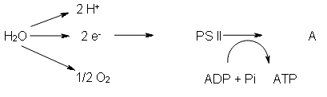
In this experiment, DCPIP (2,6-dichlorophenol-indophenol), a blue dye in oxidised form, acts as an electron acceptor and becomes colourless when reduced, allowing any reducing agent produced by the chloroplasts to be detected.

Procedure
(i) Small pieces of green spinach, lettuce or cabbage leaves (veins removed) are homogenated vigorously by grounding in a cold mortar or blended in cold blender containing 20 cm³ of ice cold, isotonic buffered medium. The ice cold solution deactivated enzymes to prevent reactions. The isotonic solution prevents rupturing of chloroplasts which can result from osmotic influx or efflux of water. Buffered solution maintains pH to mimic chloroplast pH that’s suitable for photosynthetic enzyme.
(ii) Filter into the beaker and pour the filtrate into pre-cooled centrifuge tubes supported in ice-water-salt bath.
(iii) Centrifuge the tubes for sufficient time to get a small pellet of chloroplasts. (e.g. 10 minutes at high speed).
(iv) Pour off the liquid (supernatant) into a boiling tube being careful not to lose the pellet.

Cuvettes are set up with the contents as listed below and monitored by a spectrophotometer
Cuvette 1 (leaf extract + DCPIP covered by aluminium foil)
Cuvette 2 (no leaf extract / boiled leaf extract + DCPIP + exposure to light)
Cuvette 3 (leaf extract + exposure to light + no DCPIP).
Cuvette 4 (leaf extract + DCPIP + Exposure to light).
(vi)When the DCPIP is added to the extracts, shake the Cuvette and note the time.
(vii)Time how long it takes to decolourise the DCPIP in each tube.
Sample results
Time (sec) | Absorbance (arbitrary units)
Time (sec) | Cuvette 1 (Dark) | Cuvette 2 (No chloroplasts) | Cuvette 3 (No DCPIP) | Cuvette 4 (All conditions)
0 | 1.08 | 1.37 | 0.80 | 1.07
20 | 1.06 | 1.37 | 0.80 | 0.90
40 | 1.06 | 1.37 | 0.80 | 0.81
60 | 1.06 | 1.37 | 0.80 | 0.71
80 | 1.05 | 1.37 | 0.80 | 0.57
100 | 1.05 | 1.37 | 0.80 | 0.47

On same axes, the results in the table above can be reflected graphically.

EXPLANATION FOR RESULTS IN THE TABLE ABOVE
Cuvettes | Observation / Description | Explanation
1 | Absorbance decreases slightly from 0 second to 20 seconds, remains constant from 20 second to 60 seconds, decreases slightly from 60 seconds to 80 seconds, then remains constant thereafter. | There was no light hence no DCPIP reduction.  The gradual decrease in the first 20 seconds is due to DCPIP being reduced when light hit the chloroplasts in the brief moment before the cuvette was wrapped by aluminium foil.
2 | Absorbance remains constant from 0 seconds to 100 seconds | No reduction of DCPIP occurred, due to absence of chloroplasts.
3 | Absorbance remains constant from 0 seconds to 100 seconds. | No reduction was detected without DCPIP hence the mixture didn’t change from its original colour.
4 | Absorbance of the reaction mixture decreases fast from 0 seconds to 100 seconds. | Presence of light enables the live chloroplasts to release electrons that were accepted by DCPIP to become reduced, which was shown by the colour change from blue to colourless hence enabling absorbance.

CONCLUSIONS
Cuvette 1: Light is necessary for DCPIP reduction.
Cuvette 2: Chloroplasts are necessary for reduction of DCPIP.
Cuvette 3: Chloroplasts do not affect the changes in absorption of the DCPIP solution.
UNDERWATER PHOTOSYNTHESIS
Major photosynthetic challenges under water
(i) reduced carbon dioxide diffusion rate, which is overcome by supplementary use of HCO₃⁻ (bicarbonate ions)
(ii) low light penetration with depth.
The rate of light penetration in a body of water depends on suspended substances and the turbidity of the water.
Turbidity greatly affects the penetration of light in aquatic environments by absorbing and scattering light.
Heavy growth of phytoplankton blocks the light very effectively.
Untreated, raw sewage adds suspended solids when dropped in water, which block effective light penetration in water.

Cuvette 4: Light is necessary for the release of electrons from live chloroplasts.
Cuvettes 1, 2, 3 work as control experiments.
If transmittance is used, the results can be reflected graphically as shown below
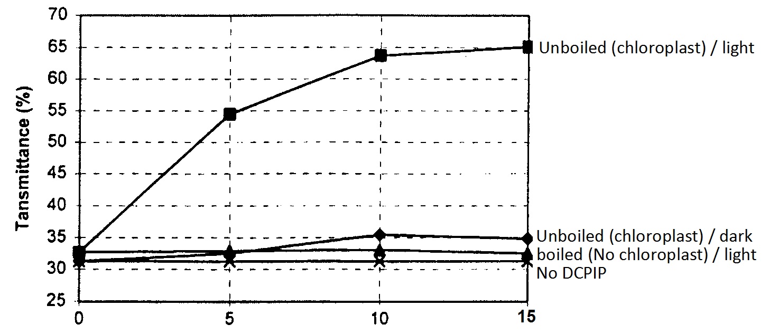

FACTORS WHICH AFFECT PHOTOSYNTHESIS
(1) carbondioxide concentration (2) Light intensity (3) Temperature (4) Chlorophyll concentration (5) oxygen concentration (6) Water and dissolved nutrients (7) Enzyme inhibitors e.g. cyanide, dichlorophenyl dimethyl urea – DCMU (8) Some air pollutants e.g. Sulphur dioxide (9) Altitude (10) Salinity

THE PRINCIPLE OF LIMITING FACTORS
It states that: ‘At any given moment, the rate of a chemical process is limited by the one factor which is nearest its minimum value, and by that factor alone’
Graph illustrating the concept of limiting factors on the rate of photosynthesis

Salinity
One of the major effects of salinity is osmotic stress, and hence there are intimate relationships to drought stress or ‘water stress’. This results in stomata closure in an effort to avoid desiccation, which reduces photosynthesis because uptake of CO₂ reduces.

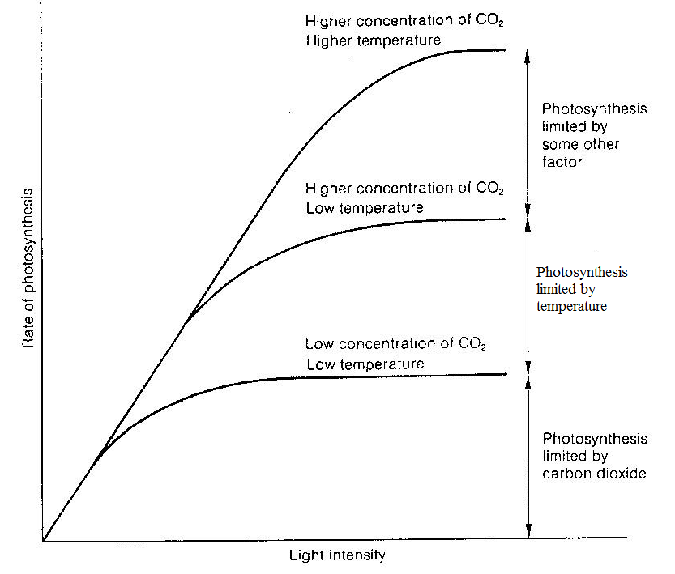

Effect of carbon dioxide
In the atmosphere, the concentration of carbon dioxide ranges from 0.03 to 0.04 %
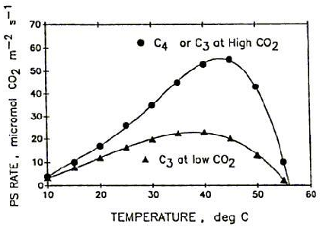

Observation / description | Explanation
● Generally, the rate of photosynthesis increases rapidly with increasing CO₂ concentration to a maximum at 30 Pa in C4 plants and 90 Pa in C3 plants and thereafter remains constant. | ● RuBISCO attaches carbon dioxide instead of oxygen, because the CO₂ concentration is higher than the oxygen concentration.  More cells photosynthesize because of the increased carbon dioxide molecules available.
● The rate of photosynthesis is faster in C4 than C3. | PEPC of C₄ has a higher affinity for carbondioxide than RuBISCO of C₃ and hence acts faster.
● The overall photosynthetic products are greater in C3 than in C4 | C4 needs more ATP than C3 which generally reduces photosynthetic out put
● The C4 plants are more efficient at lower CO₂ concentration while C3 more efficient at higher CO₂ | ● At lower CO₂ concentration in C3 photorespiration reduces the photosynthesis efficiency yet PEPC has a high affinity for CO₂
● C₃ plant has a higher compensation point than C₄ | PEPC has a high affinity for carbon dioxide
After attaining the maximum, the rate of photosynthesis remains constant in both | It is because other factors limit the process e.g. temperature, light intensity etc.
● At the CO₂ concentration of about 70 Pa, the rate of photosynthesis is equivalent in both plants

Chlorophyll Concentration
The concentration of chlorophyll affects the rate of reaction as they absorb the light energy without which the reactions cannot proceed.
Temperature
An optimum temperature ranging from 25ºC to 35ºC is required. At temperatures around 0ºC the enzymes stop working and at very high temperatures the enzymes are denatured.
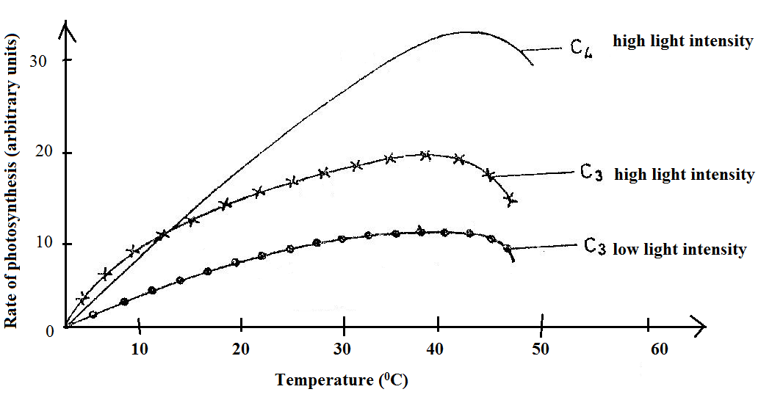

Observation / description | Explanation
Below 10⁰C, C₃ rate of photosynthesis is higher than in C₄ above 10⁰C. | C₄ photosynthetic enzymes are less active in the cold but become more active with increase in temperature.
The maximum rate of photosynthesis attained in C₄ is much higher than in C₃ | The optimum temperature for enzymes involved in the C₄ cycle is higher than in the C₃ cycle
At about 45⁰C, the rate of photosynthesis decreases | Enzymes controlling photosynthesis are denatured
There is an initial increase in photosynthetic rate to a maximum at about 40-42⁰C, inspite of further increase in temperature | Light intensity becomes a limiting factor in each of the three cases
There is increase in the rate of photosynthesis with increase in temperature until up to at about 40⁰C | Increase in temperature activates enzymes to a level beyond which enzyme denaturation occurs.

Water: In response to drying, leaves close their stomata to conserve water being lost as water vapour through them.
Pollution: Soot blocks stomata and reduce the transparency of the leaves, which reduces photosynthesis.

Light intensity and Compensation Point
Low light intensity lowers the rate of photosynthesis. As the intensity is increased the rate also increases. At maximum intensity there is no effect on the rate. Very high intensity may, in fact, slow down the rate as it bleaches the chlorophyll.
Compensation point: The light intensity at which the photosynthetic intake of carbon dioxide is equal to the respiratory output of carbon dioxide. It occurs during early morning or late evenings
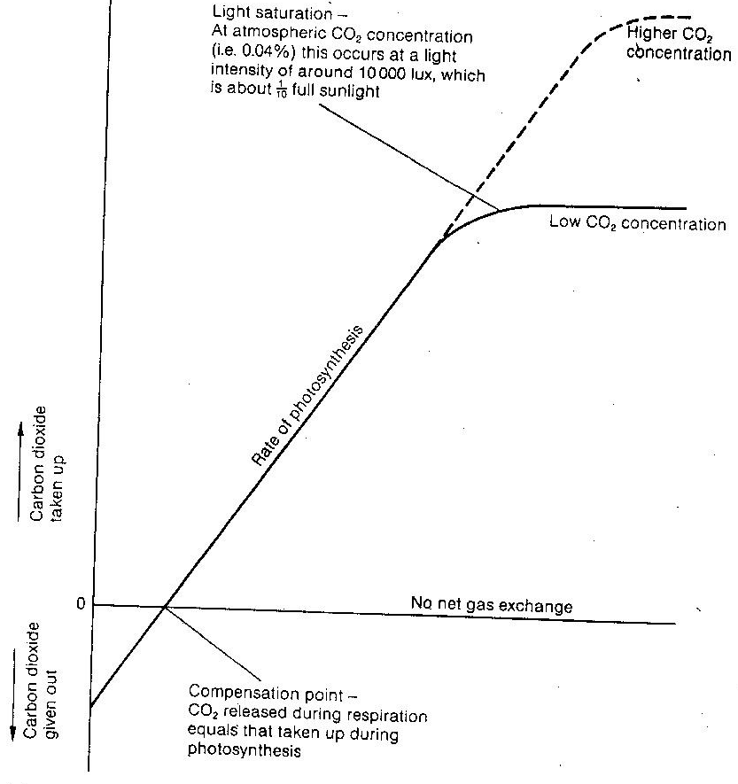

Effect of altitude (and oxygen)

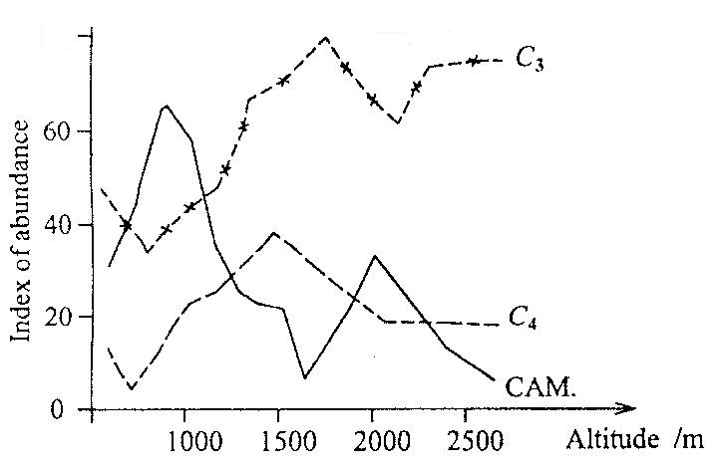

Effect of altitude explained
Observation / description | Explanation
C3 plants are more abundant at high altitude/elevation | The decrease in atmospheric pressure at higher altitude decreases the partial pressure of oxygen enables more productivity since photorespiration reduces
CAM plants are more abundant at low altitude | Even when temperature is high, nocturnal stomatal opening and closure in day light enables them to reduce transpiration.  CAM plants that store a lot of malate and due to the thus high osmotic value also a lot of water, are usually less frost resistant than C₃ plants.
C4 plants are widely distributed at low altitude and slight elevation | Enzymes are tolerant to high temperatures and the Kranz mesophyll anatomy shields RuBISCO in bundle sheath cells from much O₂ to avoid photorespiration.
RESPONSE OF LEAF DISCS FROM SUN AND SHADE PLANTS TO GREEN LIGHT
● Several leaf discs from a sun plant and a shade plant are put in two separate 10 cm³ capacity syringes containing sodium hydrogen carbonate solution (source of carbon dioxide).
The air is sucked out of them so that they sink, then they are illuminated with white light.
As they photosynthesise, the oxygen produced makes them re-float, while the time taken to rise is noted.
Calculate the average time for the leaf discs to float
The experiment is repeated, this time covering the syringes with a green filter, so that the discs are illuminated with green light and the time taken for leaf discs to rise is noted again.
Calculate the average time for the leaf discs to float as before.
OBSERVATION:
(1) Leaf discs from shade plants eventually float, an indicator that they are able to use green light for photosynthesis.
(2) Leaf discs from sun plants sink at bottom of the container which indicates that they cannot use green light to photosynthesise.

NOTE
1. Time taken for leaf discs to float can thus be used as an indirect measure of the rate of photosynthesis i.e. the more quickly flotation occurs, the faster the rate of photosynthesis.
2. The experimental results mimic the conditions in the plant’s natural habitat i.e. the sun plant in the canopy receives white light and absorb the blue and red light from it in order to photosynthesise while the shade plant receives light that has already passed through the canopy, . In order to photosynthesise it absorbs many other wavelengths of light, including green.

MEASUREMENT OF RATE OF PHOTOSYNTHESIS
(i) Measure the uptake of CO₂ (ii) Measure the production of O₂ (iii) Measure the production of carbohydrates
(iv) Measure increase in dry mass

MEASURING THE UPTAKE OF CO₂
Uptake of CO₂ can be measured with the means of an Infra-Red Gas Analyser (IRGA) which can compare the CO₂ concentration in gas passing into a chamber surrounding a leaf / plant and the CO₂ leaving the chamber. The soil and roots must NOT be in the bag to avoid CO₂ production from respiration

EXAMPLE
In an investigation of photosynthesis, the rate of carbon dioxide absorption by leaves of two plants, barley and sugar cane, was measured. The leaves were provided with air, moving at a constant rate, through an apparatus shown below:
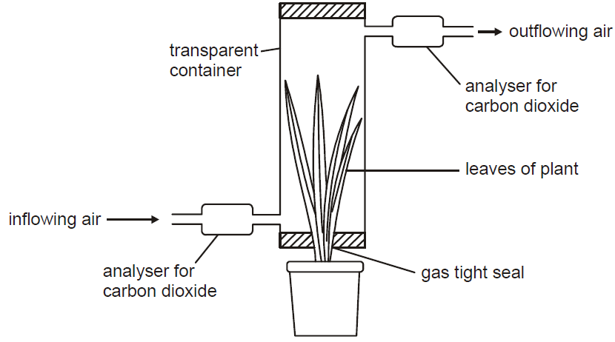
EXPERMENTAL CONDITIONS
● Light intensity was kept constant and high, equivalent to full sunlight.
● Concentration of CO₂ in air entering the apparatus could be varied.
The carbon dioxide taken up or given out by the leaves was determined by
calculating the difference between the concentration in the inflowing and
outflowing air.
● Leaves remained attached to the plants during the investigation.
Two different temperatures, 10 °C and 25 °C, were used for each type of plant.

The results of the investigation
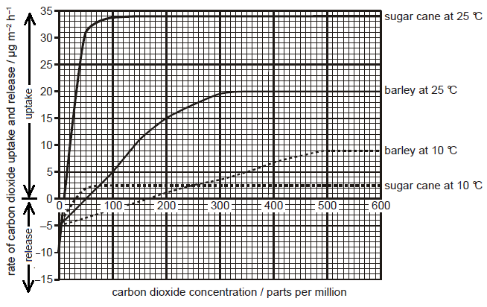

(a) For each plant species, describe the observed carbon dioxide uptake / release at the different temperatures (11 marks)
(b) Explain the observed carbon dioxide uptake / release in the two species at the different temperatures. (08 marks)
(c) Explain why all the measurements were made at the same light intensity.
(d) Suggest why it was important that the leaves remained attached to the plants while the measurements were made.
(e) Compare the response of the two species, sugar cane and barley, to differences in carbon dioxide concentration and temperature.

NOTE: CO₂ uptake can also be measured by following the uptake of carbon dioxide labelled with 14C

● Production of carbohydrates
This is a crude method where a disc is cut out of one side of a leaf (using a cork borer against a rubber bung) and weighed after drying. Some weeks later, a disk is cut out of the other half of the leaf, dried and weighed. Increase in mass of the disc is an indication of the extra mass that has been stored in the leaf.
However, you can probably think of several inaccuracies in this method.

● Measuring the increase in dry mass
Dry mass is often monitored by the technique of 'serial harvests' where several plants are harvested, dried to constant weight and weighed - this is repeated over the duration of the experiment so as to have an accurate measure of the surplus photosynthesis over and above the respiration that has taken place. As with most methods, several plants are needed to have replicate measurements which are used to calculate the average and a standard deviation if necessary.

● Measuring the production of O₂
Oxygen can be measured by (a) counting bubbles evolved from pond weed with the Audus apparatus
Requirements
(1) Previously well illuminated aquatic plant e.g. Elodea or Cabomba (2) Test tube (3) Watch (4) Water at room temperature (5) bench lamp to provide light (6) Knife (7) Ruler (8) 0.2 % sodium bicarbonate solution (9) plastic Syringe (10) 500 cm³ glass beaker (11) capillary tube (12) plastic tube connector (13) graduated scale (14) retort stand (15) soft board (16) thermometer
Procedure:
Set up the apparatus as below in TOTAL DARKNESS
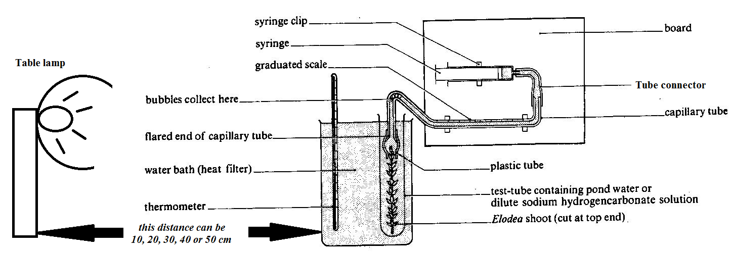

(1) A light source is placed 50 cm away facing the test tube, is powered on and a 5 minutes lapse is allowed to enable the plant adjust to the light intensity.
(2) The length of gas bubble evolved in 10 second, 30 second, and 1 minute intervals is measured by pulling the syringe plunger to draw the bubble slowly along the capillary tube.
(3) Steps 1 and 2 are repeated with the light source placed at 40 cm from the test tube with the plant, then 30 cm, 20 cm, and finally 10 cm.
(4) Lastly the control experiment involves using natural room lighting and repeating the above steps.
Observation / results | Explanation
● A colorless gas which relights a glowing splint evolves from the cut end of the plant. | ● The gas is oxygen released from Photosynthetic reactions.
● The rate of gas evolution is directly proportional to light intensity up to a certain illumination i.e. the closer the light source is to the plant, the more oxygen bubbles evolve up to a certain light intensity then remains relatively constant and may decrease.  Determination of amount of gas released  a) if scale is marked in mm³ or cm³: read volume directly  b) if scale is marked in mm: calculate volume from πr²h  π=3.14, r=capillary tube radius, h=distance bubble covers | This is because of the increased light intensity which provides more energy for photo-activation of electron flow.   Increased illumination may not cause any further evolution of oxygen because (1) of light saturation (2) other factors limit the process   Increased illumination may cause a decrease in bubble evolution because chlorophyll gets bleached with increased illumination.

Precautions to avoid experimental inaccuracies / errors | Explanation / Remedy
● Temperature fluctuation of the water in the beaker | ● Thermostatically controlled bath should be used to maintain temperature constant since it affect photosynthetic activity.
● The experiment must be conducted in total darkness | ● To avoid effects of external light fluctuations on photosynthesis
● There must be periodical refilling of HCO₃⁻ solution | ● To avoid depletion of carbondioxide
● The water should be aerated first. | ● To saturate the water with oxygen such that the oxygen evolved does not dissolve into water.
● Each time the light position is adjusted, a 5 minute lapse must be allowed before bubble counting | ● To allow the plant equilibrate (adjust) to the new light intensity.
Light intensity fluaction | Use voltage that gives constant light for a long time
Trapped gas bubbles | Swirl the water weed to release them
● Expel gas before taking another reading | ●

NOTE:
● Instead of measuring the length of bubble, bubbles can be counted, but this has several disadvantages (1) Some bubbles may not be seen due to variations in size, which can be avoided by adding a little detergent to lower the surface tension (2) Bubbles may evolve very fast to be counted, especially in much illumination.
The percentage of oxygen in the evolved gas is only about 40% because of dilution by (1) dissolved N₂ or other gases released from solution and (2) CO₂ which had accumulated from respiration, and is first displaced into the capillary tubing, especially if the plant had been kept in the dark
RELATIONSHIP BETWEEN PHOTOSYNTHESIS AND RESPIRATION
There is a close relationship between the activities of respiration and photosynthesis in living things. These two activities counteract each other in many ways, and a balance of the processes are necessary to maintain the favourable O₂/CO₂ ratio in the atmosphere.
In the presence of light, plants respire aerobically to release carbon dioxide while consuming oxygen, and at the same time photosynthesise to release oxygen while consuming carbon dioxide, although photosynthesis far exceeds respiration.
In darkness, plants respire aerobically to release carbon dioxide but photosynthesis is inhibited by absence of light.

SAMPLE QUESTIONS
1. Five small discs cut from spinach leaves were floated on a small volume of buffered hydrogen carbonate solution in a flask attached to a respirometer. The discs were first exposed to bright light, then to dim light and finally left in the dark. Oxygen release was recorded as positive values and oxygen uptake as negative values as given in the table below.
(a) Present the data in a suitable graphical form
(b) (i) Calculate the mean rate of oxygen release in bright light
(ii) Explain the significance of the results obtained from this experiment.

(c) Explain the use of the following in the experiment above:
(i) Five small leaf discs, not one.
(ii) Hydrogen carbonate solution
(iii) Buffered hydrogen carbonate solution

Light intensity | Time interval in minutes | Oxygen uptake or release in mm³
Bright light | 0 – 3  3 – 6  6 – 9  9 – 12 | +57  +64  +58  +60
Dim light | 12 – 15  15 – 18 | +16  +3
Dark | 18 – 21  21 – 24  24 – 27  27 – 30 | - 16  - 12  - 15  - 14

2. In an experiment, samples of algae were collected at 1-minute intervals over a period of 5 minutes. The quantities of glycerate-3-phosphate (GP) and ribulose bisphosphate (RuBP) were measured. At the beginning of the experiment, the concentration of carbondioxide supplied was high. After 2 minutes, the concentration of carbondioxide was reduced. The graph in the figure below shows the results of this experiment.
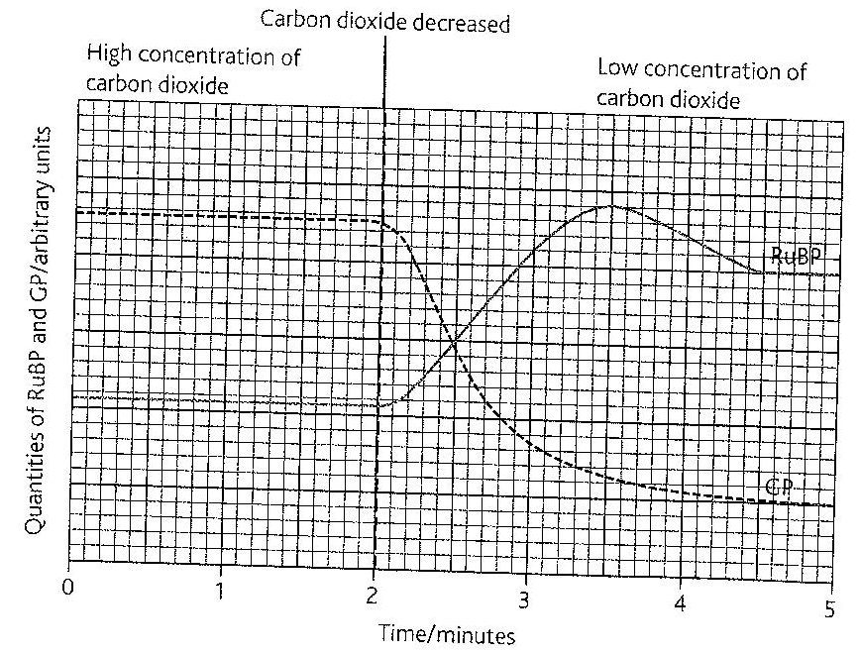
Describe the effects of the decrease in carbondioxide after 2 minutes on:
(i) Glycerate 3-phosphate (GP)
(ii) Ribulose bisphosphate (RuBP)
(b) Suggest explanation for these changes to the levels of glycerate 3-phosphate (GP) and RuBP

3. Experiments on cultures of a unicellular protist to investigate the effect of light and carbon dioxide on certain metabolites. In the first experiment, the levels of PGA, RuBP and sucrose in the protest were determined at different time intervals in the presence of light. At the 35th minute, light was switched off, suddenly putting the protists in darkness; the results are shown in the table below
Time (minutes) |  | 0 | 20 | 35 | 40 | 50 | 60 | 70
Amount of metabolite | RuBP | 35 | 35 | 35 | 30 | 15 | 10 | 10
Amount of metabolite | PGA | 45 | 45 | 45 | 50 | 65 | 70 | 70
Amount of metabolite | Sucrose | 10 | 54 | 72 | 66 | 52 | 35 | 20
(a) Represent the data provided graphically
(b) Using the graph obtained in (a) above, explain the variation in the levels of the metabolites with time
4. The rate of photosynthesis of Digitaria bipartite, a C4 plant and Astropa belladonna, a C3 plant was investigated under different intracellular carbon dioxide concentrations. The results are shown in the table below
Carbon dioxide concentration (ml per dm³) | Rate of photosynthesis (mol of CO₂ assimilated per m² of leaf area per second)
Carbon dioxide concentration (ml per dm³) | Digitaria bipartite | Digitaria bipartite
0 | 0.0 | 0.0
25 | 12.5 | 0.0
50 | 35.0 | 5.0
75 | 37.5 | 14.0
100 | 37.5 | 25.0
150 | 37.5 | 40.0
200 | 37.5 | 47.5

(a) Present the data in the table above graphically
(b) Compare the rates of photosynthesis of two plants at the carbon dioxide concentrations shown in (a) above
(c) Explain your answer in (b) above
(d) Explain, in biochemical terms, the distribution of C₃, C₄ and CAM plants at their environments
5. The table below shows how the rate of photosynthesis of C4 and C3 plants vary with the temperature at different light intensities. The rate is in arbitrary unit.
Temperature/⁰C | 0 | 5 | 10 | 20 | 30 | 35 | 40
C₄ plants at high light intensity | 0 | 5 | 12 | 25 | 28 | 32 | 38
C₃ plants at high light intensity | 0 | 10 | 12 | 15 | 18 | 20 | 10
C₃ plants at low light intensity (Arbitrary units) | 0 | 2 | 5 | 8 | 10 | 10 | 6
(a)Represent the above results graphically on the same axes.
(b) Explain how differently temperature affects photosynthesis in C₃ plants and C₄ plants.
(c) Explain the pattern of the graph obtained for C₃ plants under low light intensity.
(d) Explain the effect of light intensity on the following.
(i) Leaf colour (ii) Leaf size (iii) Internode length
(e) State three other factors that may limit the rate of photosynthesis.
6. The table below shows effect of temperature on rate of photosynthesis in two grasses, Agropyron and Bouteloua
Leaf temperature (⁰C) | Rate of photosynthesis in arbitrary units
Leaf temperature (⁰C) | Agropyron | Bouteloua
10 | 23 | 10
15 | 26 | 15
20 | 30 | 19
25 | 31 | 24
30 | 30 | 30
35 | 27 | 35
40 | 20 | 39
45 | 10 | 38
(a) Plot the data on a graph paper (b) Compare the rate of photosynthesis in the two plants.
(c) Account for the variation of the rate of photosynthesis in the two plants.
(d)(i) Describe the photosynthetic mechanism which is likely to occur in the cytoplasm of the mesophyll of Bouteloua
(ii) Explain the physiological significance of the mechanism described in (e) (i) above.
6. (a) Explain the effect of light intensity and temperature on the rate of photosynthesis.
(b) Explain photophosphorylation in terms of chemiosmosis.
(c) Explain the reactions involving the use of light energy that occur in the thylakoids of the chloroplast.
7. (a) Outline the light-independent reactions of photosynthesis.
(b) (i) Explain: (i) why the light-independent reactions of photosynthesis can only continue for a short time in darkness.
(ii) how the light-independent reactions of photosynthesis rely on light-dependent reactions.
8. (a) Outline the formation of carbohydrate molecules in photosynthesis starting from the absorption of light energy
(b) Compare the structure of a chloroplast and a mitochondrion in relation to function.
9. (a) Explain how a photosystem increases the light harvesting ability of a chloroplast?
(b) Explain the relationship between the action spectrum and the absorption spectrum of photosynthetic pigments in green plants.
(c) Explain the concept of limiting factors in photosynthesis, with reference to light intensity, temperature and concentration of carbon dioxide.

